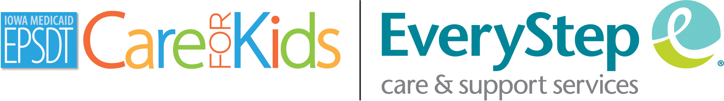
Medicaid/Title 19 Pediatricians (Children’s Doctors)
Polk County (Ankeny)

*Urgent Care and other operations may be impacted by the COVID-19 pandemic. Please call clinics for information. *

Vaccine clinics- know where/when in each county
Dallas County: Dallas County Health Dept every other Tuesday 3:30-5:30
Immunization Services | Dallas County, IA
Warren
Public Health Programs - Warren County, Iowa
Madison
Public Health | Madison County, Iowa - Madison County Iowa
Polk:
(One thing I’ve heard about Polk is that they make you do ALL vaccines that are due, even flu/covid, so we will need to fact check that. I’ve had folks choose to go to Warren County for immunizations instead due to this)
Childhood Immunizations - Polk County Iowa
*Accepted insurance is subject to change with each provider. Please double-check with your provider to see if your insurance is accepted.

GENERAL INFORMATION
Clinic Name | Interpretation
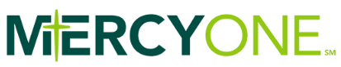  (All Locations) | Interpretation available at most locations. Please request interpreter when scheduling an appointment.
  (All Locations) | Interpretation available. Please request interpreter when scheduling an appointment.
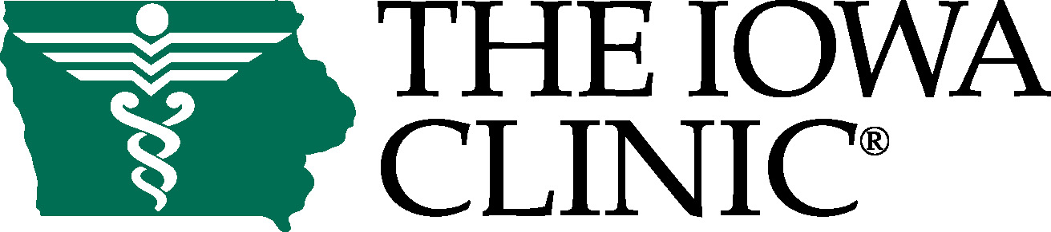  (All Locations) | Interpretation available. Please request interpreter when scheduling an appointment. Interpreter will be confirmed within 24 hours.
Primary Health Care    (All Locations) |  | Interpretation available. Please request interpreter when scheduling an appointment.
Broadlawns East University Clinic   | - Interpretation available.  - Specialties: Mental health, ophthalmology, midwifery, physical therapy.

Find a Provider (MCO Website)
IA Total Care:
https://findaprovider.iowatotalcare.com/location

Molina:
https://passport.sapphirethreesixtyfive.com/?ci=ia-molina&network_id=117&geo_location=41.6163,-93.5509&locale=en
*Note: Client will need to put in their zip code to see what clinic is closes to them

Wellpoint:
https://findcare.wellpoint.com/fc-landing

DES MOINES
Clinic Name/Providers | Contact Info/Hours | Additional Information | Insurance Accepted
Blank Children’s Adolescent Medicine  1212 Pleasant St. Ste 406  Des Moines, IA 50309 | 515-241-8336  Monday-Friday  8am-4:30pm | - Appointments required.  - Patients aged 12-21 years only.  - Interpretation available in-person or via phone service. | ☒ Medicaid  ☒ Hawki  ☒ Wellpoint  ☒ Iowa Total Care  ☒ Molina Healthcare  ☒ Other private insurance
Blank Children’s Pediatrics  1212 Pleasant S. Ste 300  Des Moines, IA 50309 | 515-241-8923  Monday-Friday  7:00am-6:00pm  Saturday  9:00am-2:00pm | - Appointments required.  - Payment Plans available.  - Interpretation available via phone service and on-site. | ☒ Medicaid  ☒ Hawki  ☒ Wellpoint  ☒ Iowa Total Care  ☒ Molina Healthcare  ☒ Other private insurance
Broadlawns Pediatric Clinic  1801 Hickman Rd  Des Moines, IA 50314 | 515-282-2700  Monday-Friday  8am-4pm | - Appointments required.  - Interpretation available via phone service and on-site. | ☒ Medicaid  ☒ Hawki  ☒ Wellpoint  ☒ Iowa Total Care  ☒ Molina Healthcare  ☒ Other private insurance
Des Moines Pediatric and Adolescent Clinic - Beaverdale2301 Beaver Ave  Des Moines, IA 50310 | 515-255-3181  Monday–Friday:  9am to 5 pm  (Phones open at 8a)  Saturday: 9am to 12pm | - Appointments required.  - Payment plans available.  - No interpretation provided  - Two locations. See also: Ankeny. | ☒ Medicaid  ☒ Hawki  ☒ Wellpoint  ☒ Iowa Total Care  ☒ Other private insurance
MercyOne Des Moines Pediatrics Care Clinic  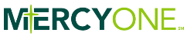  330 Laurel St., Ste 2100  Des Moines, IA 50314 | 515-643-8611  Schedule Online  Monday- Friday  7:30am- 4:00pm  Urgent Care/Walk-in  Monday-Friday  7:30-8:30am | - Walk in times available.  - Payment Plans available.  - Interpretation services available. | ☒ Medicaid  ☐ Hawki  ☒ Wellpoint  ☒ Iowa Total Care  ☒ Molina Healthcare  ☒ Other private insurance
UnityPoint Clinic Pediatrics – Methodist PlIaza  1221 Pleasant St. Ste 170  Des Moines, IA 50309 | 515-241-4300  Monday- Friday  7:00am-5:00pm | - Appointments required.  - Same-day appointments available.  - Interpretation available in-person or via computer software. | ☒ Medicaid  ☒ Hawki  ☒ Wellpoint  ☒ Iowa Total Care  ☒ Molina Healthcare  ☒ Other private insurance

PLEASANT HILL
Clinic Name/Providers | Contact Info/Hours | Additional Information | Insurance Accepted
MercyOne Pleasant Hill Pediatrics Care Clinic  5900 E University Ave  Suite 300  Pleasant Hill, IA 50327 | 515-643-2600  Schedule Online  Monday-Friday  7:45a-5p  Urgent Care/Walk-In  7:45am-8:45am | - Urgent Care/Walk-in Hours available.  - Interpretation available via phone service.  - Payment plans available. | ☒ Medicaid  ☒ Hawki  ☒ Wellpoint  ☒ Iowa Total Care  ☒ Molina Healthcare  ☒ Other private insurance

